16th December 2020

YOKOHAMA in CDP’s 2020 Climate Change A List
Second year in a row, third time overall

YOKOHAMA is proud to announced that it has once again been recognized for leadership in corporate sustainability by the global environmental non-profit CDP, which named YOKOHAMA to its prestigious A List for tackling climate change on 8th December. YOKOHAMA’s selection recognizes its efforts to cut emissions, mitigate climate risks, and develop the low-carbon economy, based on its responses to the CDP’s 2020 climate change questionnaire, which received responses from more than 5,800 companies worldwide. This is YOKOHAMA’s third time on the A list, following its selection in 2016 and 2019.

CDP is a global non-profit that drives companies and governments to reduce their greenhouse gas emissions, safeguard water resources and protect forests. It leverages investor and buyer power to motivate companies to disclose and manage their environmental impacts. CDP’s platform is one of the richest sources of information globally on how companies and governments are driving environmental change.

YOKOHAMA’s GD2020 medium-term plan has designated CSR activities as an important management strategy. Accordingly, Group companies are endeavouring to create value through business activities conducted with consideration for the global environment and social contribution. In addition to activities promoting the use of renewable energy and sustainable procurement of natural rubber, Group activities that help preserve the earth’s environment include developing environmentally friendly products, installing highly efficient equipment, and conducting thorough energy-saving programs. Activities focused on social contributions include various volunteer activities by Group employees and donations by the employee-backed YOKOHAMA Magokoro Fund to support disaster relief operations and other efforts of non-profit organizations.

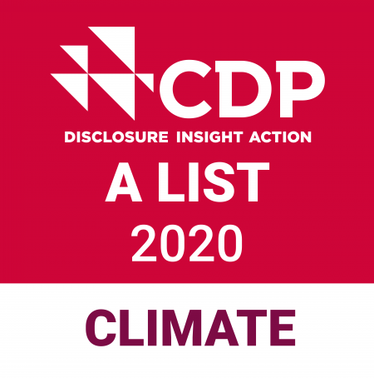
Logomark indicating selection to the CDP A List

